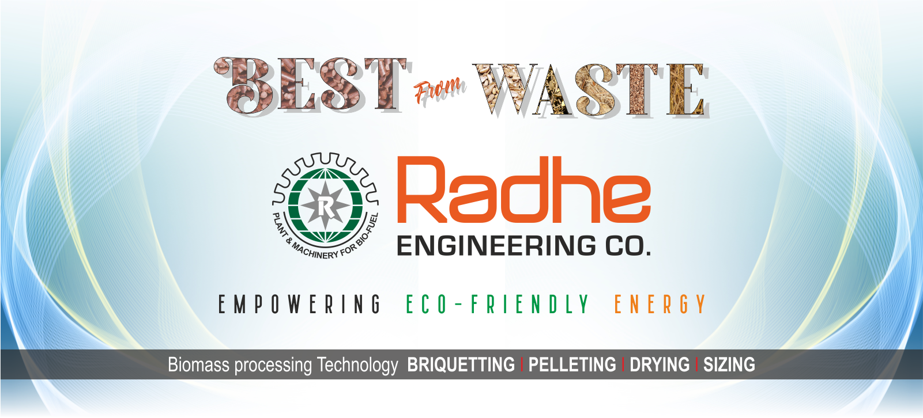

THE COMPLETE KNOW HOW
Revolutionize your energy needs with the BRIQUETTING MACHINE - the ultimate solution for turning agricultural waste into clean, renewable fuel.
- Convert biomass waste into high-density Briquettes/Bio-coal
- Maximize energy potential from non-conventional sources
- Produce a homogeneous, uniform fuel source
- Convenient and easy to use

In the face of dwindling fossil fuel reserves and skyrocketing energy demands, the BRIQUETTING MACHINE offers a game-changing alternative. This innovative machine transforms agricultural and forestry waste into a dense, uniform biofuel that burns cleanly and efficiently.

By harnessing the untapped energy potential in biomass, the BRIQUETTING MACHINE empowers you to take control of your energy needs. Whether you're a small business, a farm, or a large industrial facility, this machine can help you reduce your reliance on costly and polluting fossil fuels. Experience the power of renewable energy and enjoy the peace of mind that comes with a sustainable, environmentally-friendly fuel source.

MAJOR AGRO-WASTE AVAILABLE IN INDIA & AROUND THE GLOBE:
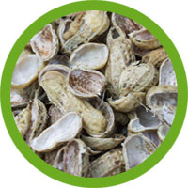  GROUNDNUT SHELL | 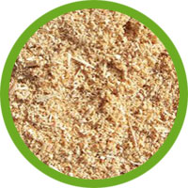  SAW DUST | 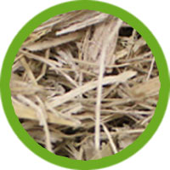  SUGARCANE BAGASSE | 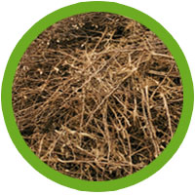  COTTON STALKS | 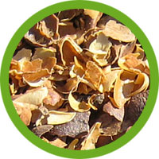  COFFEE HUSK
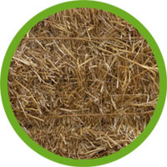  MUSTARD STALKS | 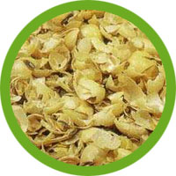  SOYABEANS HUSK | 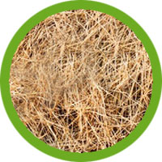  PADDY STRAW | 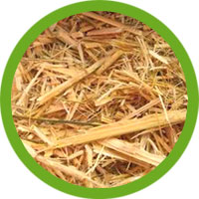  BAMBOO WASTE | 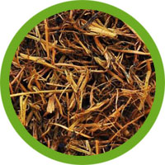  TEA WASTE
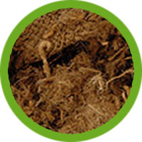  JUTE WASTE | 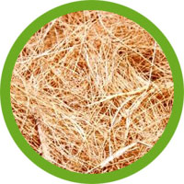  COIR PITCH | 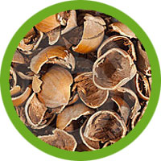  BETEL NUT SHELLS | 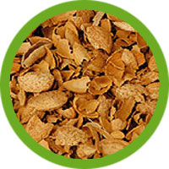  CASTER SEED SHELS |   FOREST LEAVES

- Most of the biomass can be used directly as per specification.
- If the raw material is having more than 10% of moisture contain, then it requires Drying process.
- If the raw material is longer then 20mm size, then it requires Cutting process.
- Rates of raw material are variable depending on season & location
- Availability of raw material is very important for economic viability of biomass briquetting project.
Fuel the Future: Renewable Energy Powered by Biomass Briquetting Machine
Briquettes / Bio-coal / White coal is densification of biomass to produce homogeneous, uniformly sized solid pieces of high bulk density which can be conveniently used as a fuel.
Briquettes have high specific density (1200Kg/m3) and bulk density (800 Kg/m3) compared to 60 to 180 Kg/m3 of loose biomass.
Briquette - The Fuel That Ignites Efficiency
- Eco friendly & Renewable Energy fuel
- Economical and cheaper than other solid fuels
- Thermal calorific value approx. 4000 Kcal / Kg
- Pollution free & non-hazardous
- Lower ash contains 2% - 5%. There is no fly ash when burn
- Consistent high burning efficiency
- Contain high density & higher fix carbon value
- Easy for transportation, feeding & combustion
- Combustion is more uniform due to high rise in fossil fuel prices

Energy at Work : Harnessing Earth’s Renewable Resources
Briquettes are ready substitute of Lignite / Coal / Wood in thermal applications & replaces costly liquid fuels like FO, Diesel, LDO, Kerosene etc. Use of Briquettes as a fuel for green energy has shown very promising results.
Use of Finished Briquettes in various Industries (Thermal Applications)
- Gasifier System Applications | - Vegetable Plants
- Ceramic Industries | - Textile Unit
- Refractory Industries | - Spinning Mill
- Solvent Extraction Plant | - Lamination Ind.
- Chemical Industries | - Leather Industries
- Dyeing Units | - BrickMaking Units
- Milk Plants | - Rubber Industries
- Food Processing Industries | - Any Industrial
Unlock the power of India's incentives by Government of India - Unleash your potential!
- 100 % Income Tax benefit up to 5 years
- 80% depreciation on first year
- Doesn't require NOC from pollution control board
- Prompt finance available from Nationalized bank & NBFC.
Empowering Individuals, Strengthening Communities: The Social Benefits Advantage.
- Employment generation
- Save import duty on fossil fuel
- Reduce greenhouse gases
- Control pollution
- Easy availability of various raw material
- Does not require any binder or chemical
- Excellent project viability
- Rising demand of finished Briquettes
- Short payback period
- Pollution free and non-hazardous project

